**Multi Factor Authentication Login**

1. 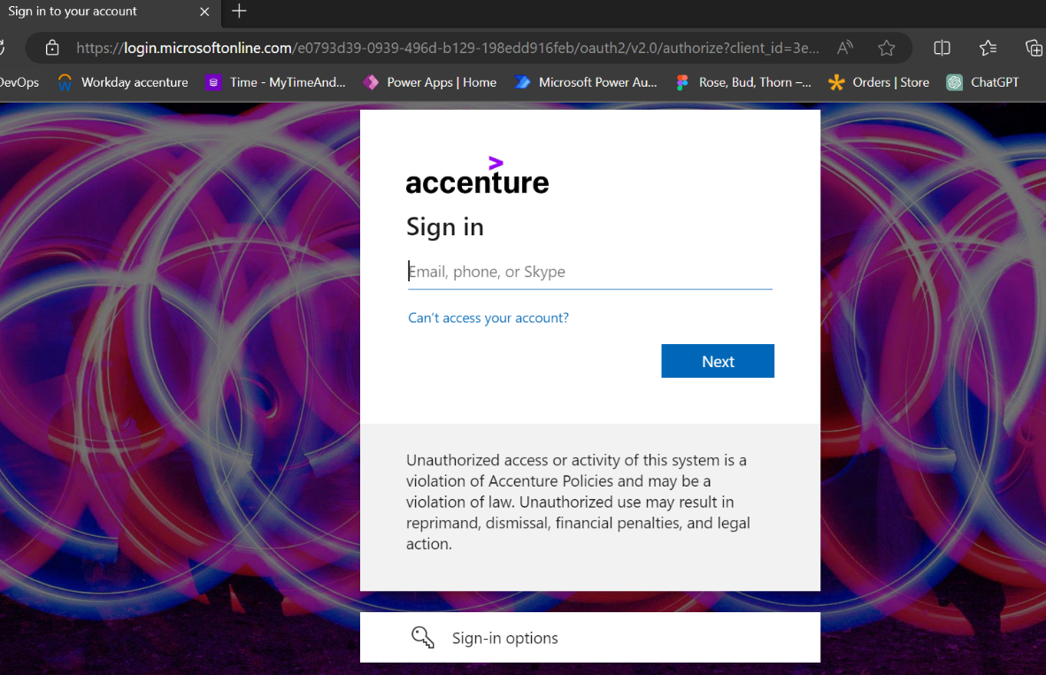**Microsoft login page**
2. 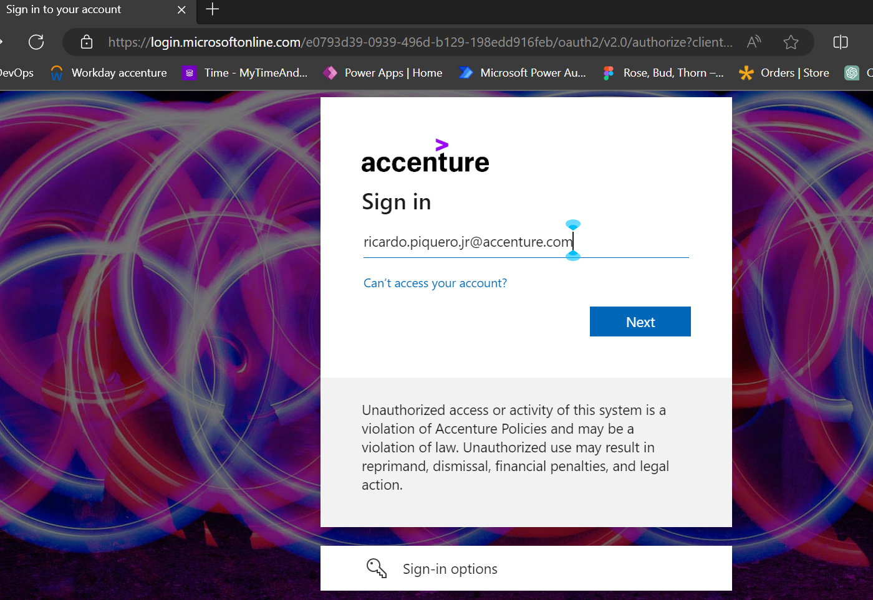**Accenture Enterprise Sign On 1st authentication (ESO)**
3. **Accenture Enterprise Sign On 2nd authentication (Microsoft Azure Authenticator)**

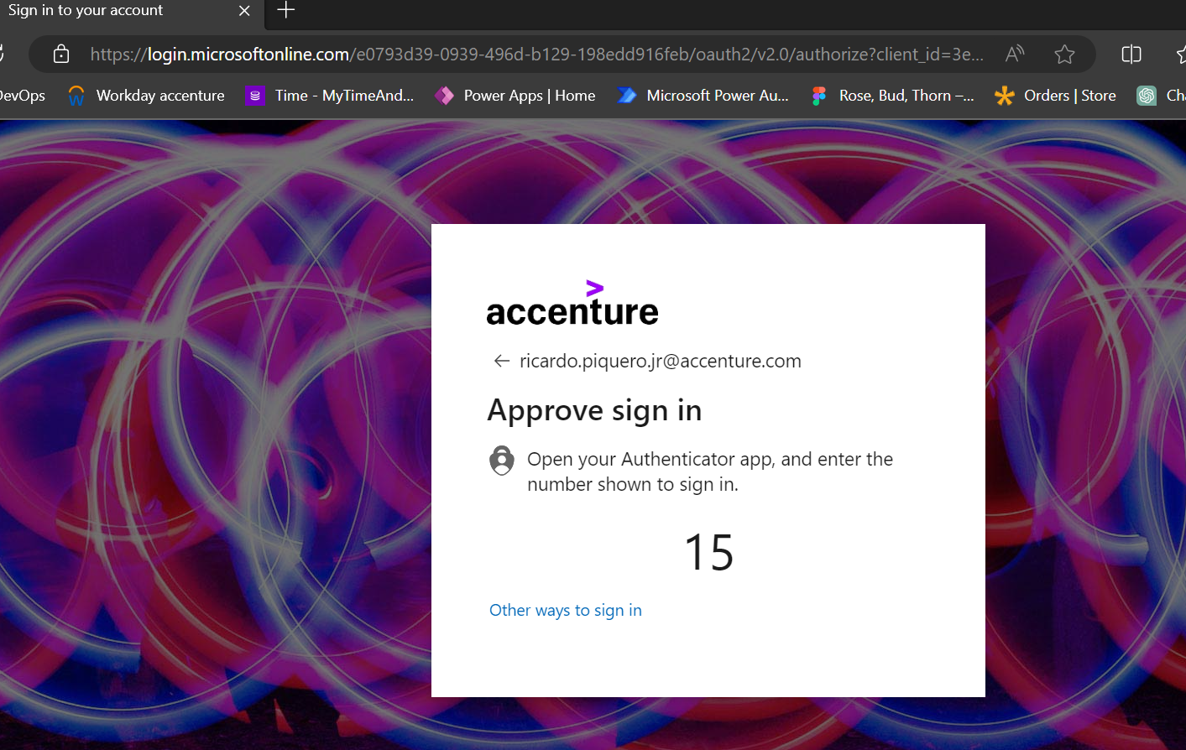

1. **Successful Login landing page of your application**

